**Homework**

How to make a webpage accessible-examples of good and bad websites

1. Disabled users

Types of disabilities:

1. Colour blindness

There are three types of colour blindness. The on that causes people to see everything in monochrome colours, the one where the person find it difficult to differentiate red and green hues and the one where the same thing happens with yellow and blue hues.

Colour blind people can have problems seeing or understanding the text on a website because of the colours that are used for background and text, so if there is important information or maybe a button that they should press on a website, they will not be able to see it.

1. Poor eyesight

Poor eyesight refers to the people who cannot see things properly, even when wearing glasses. This includes elderly people whose vision gets worse.

1. Blindness

Blind people can also research on internet. Not by viewing the websites, but by hearing everything that’s written on it. To do so, they need a program called screen reader, that reads everything on a website out loud.

Disadvantages of this program are that it doesn’t read everything that’s on the page (logos for example), and also, when there is a picture, some of the programs only say “image” and the blind person cannot know what the picture is of.

1. Both blind and deaf

Those people can only read articles by using a tactile display. Web pages can be translated into Braille symbols that they understand and feel with their fingers.

1. Techniques used to make websites accessible:
2. Headings

The correct use of headings will help screen reader users interpret your website more easily, by making it well-organised.

An example of how to use headings in a proper way is to avoid using the type of headings you used for the primary title, otherwise people could get confused. Also, skipping heading levels can lead to people wondering if content is missing.

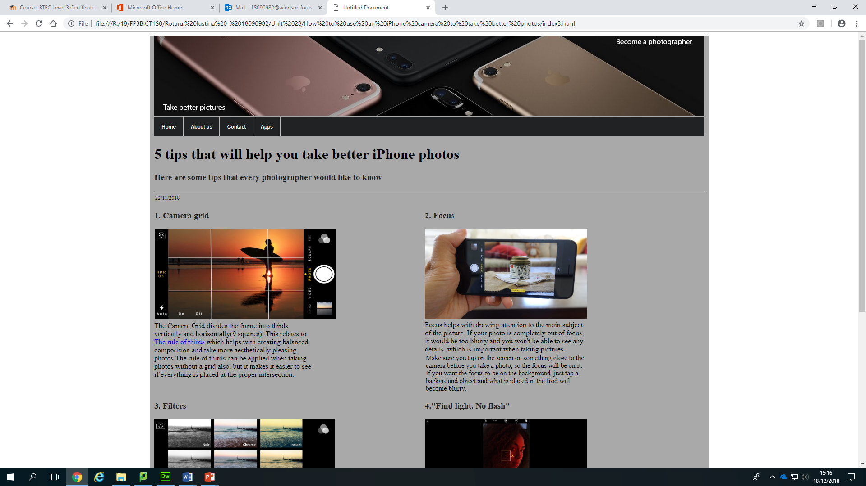

On my website, I started off with big headings which were the names of the website/pages, and continued with smaller ones. On the first page, which is this one, I created 3 types of headings. One that is bigger than everyone, one that is a little bit smaller, and the smallest ones.

1. Alt text for images

For blind people to understand completely the content on a website, knowing what the messages under the used images are. To do so, alt text has to be provided. Alt text is used to describe the images that are shown on a web page.

If a page only has images on it, then the alt text has to describe the images as good as possible so that the screen reader users can understand the content.

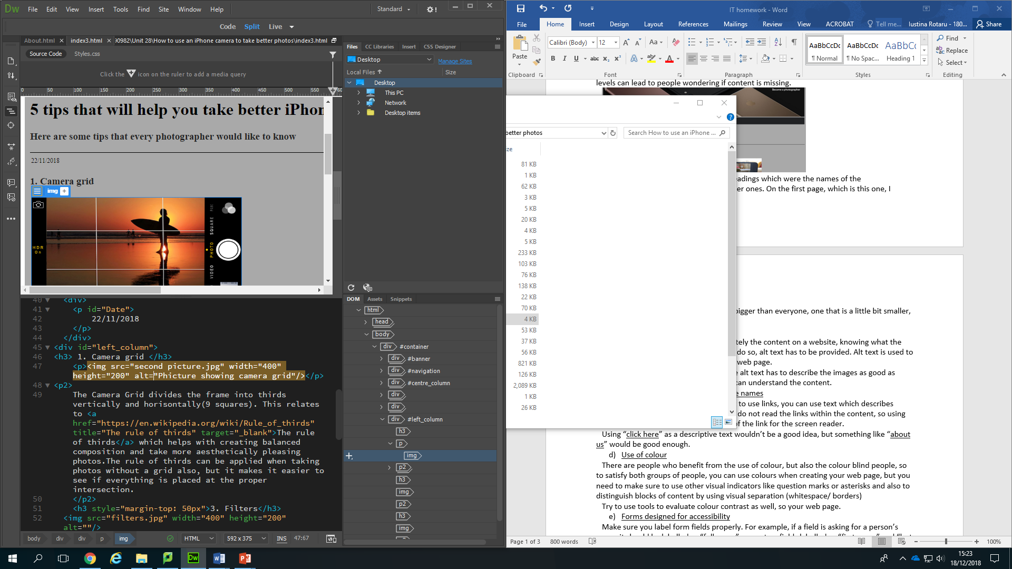

This is an example of an alt text that I put for a photo that I used on my website.

1. Links given unique and descriptive names

When creating a website and also want to use links, you can use text which describes where those links will go. Screen readers do not read the links within the content, so using descriptive text will explain the content of the link for the screen reader.

Using “click here” as a descriptive text wouldn’t be a good idea, but something like “about us” would be good enough.

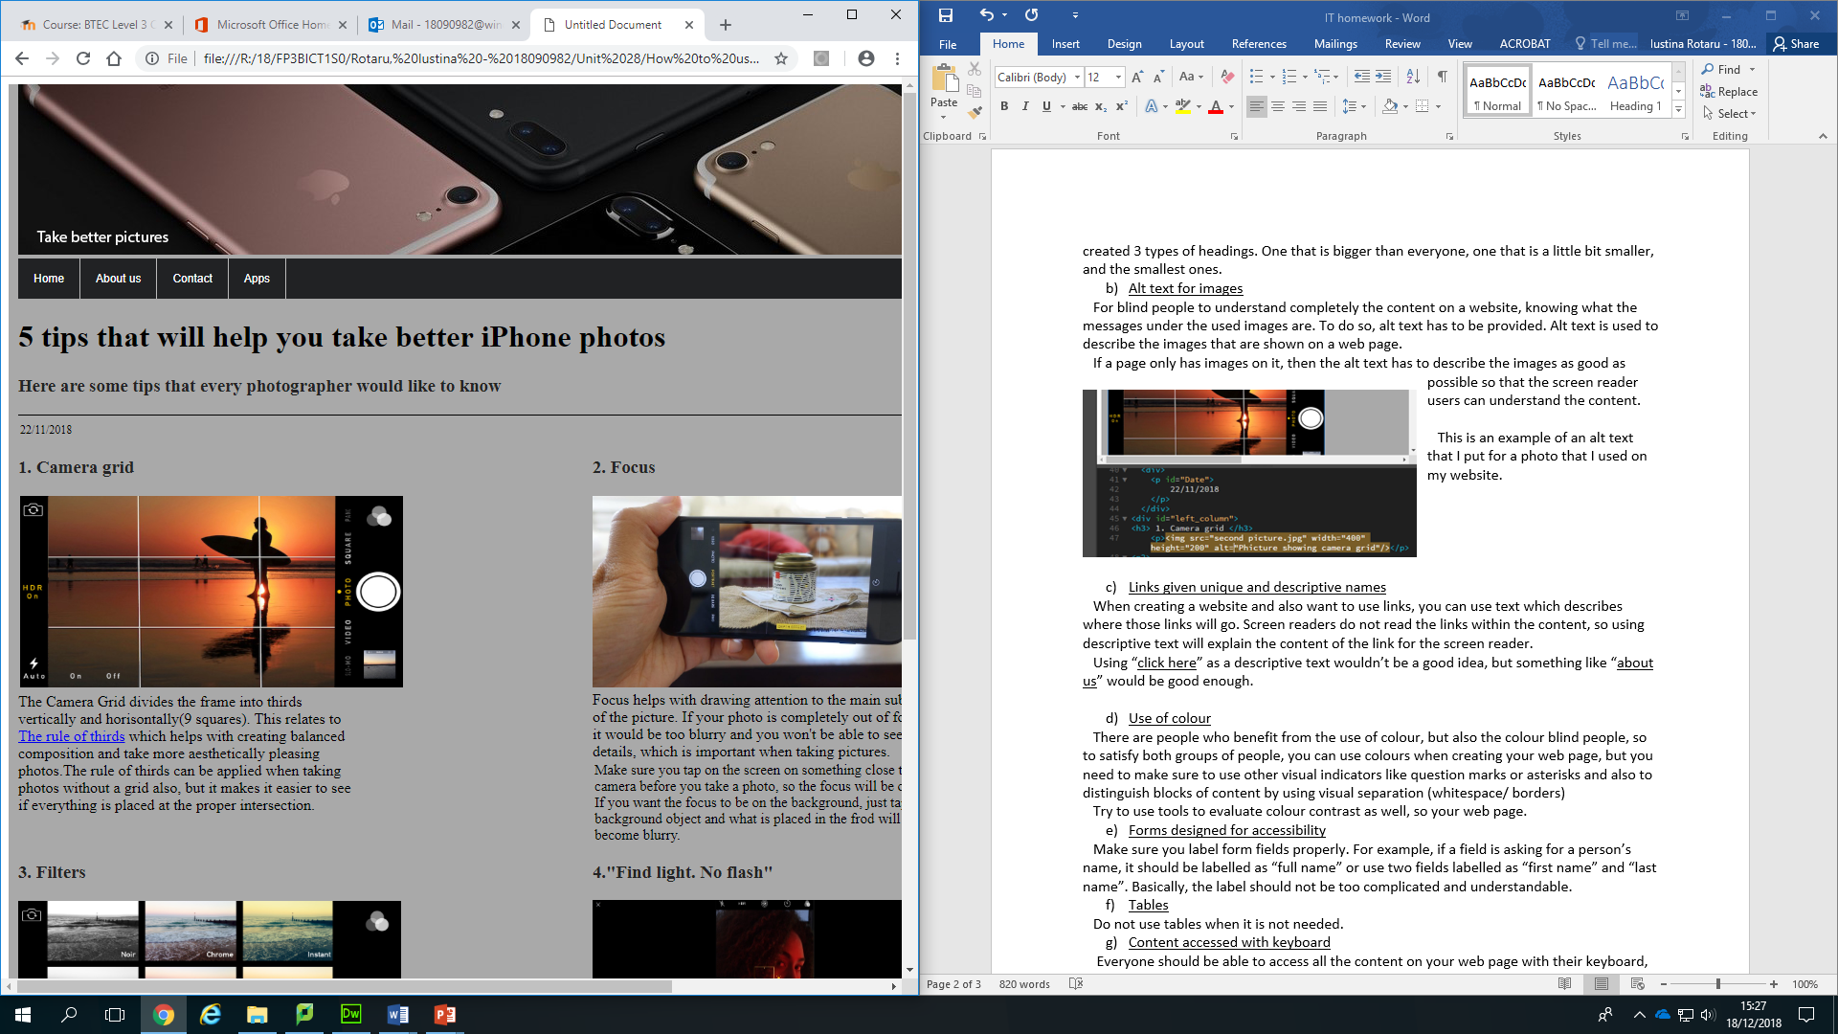

Instead of having a “click here” text for a link, I used the title of the page that I linked, and it makes it obvious that if you could click on it if you would like to know more about “The rule of thirds”.

1. Use of colour

There are people who benefit from the use of colour, but also the colour blind people, so to satisfy both groups of people, you can use colours when creating your web page, but you need to make sure to use other visual indicators like question marks or asterisks and also to distinguish blocks of content by using visual separation (whitespace/ borders)

Try to use tools to evaluate colour contrast as well.

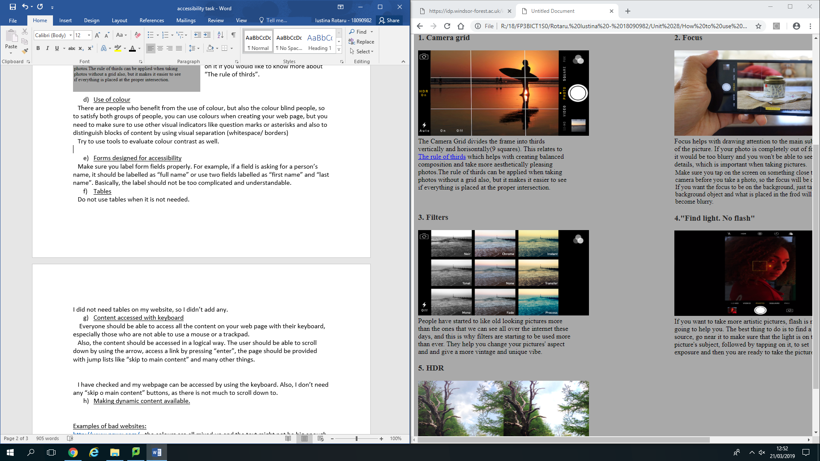

When creating my website, I decided to use black text as it is one of the best colours to use on any type of background, and the colour of my background is a light grey, otherwise people wouldn’t have been able to read anything if it had a dark colour.

1. Forms designed for accessibility

Make sure you label form fields properly. For example, if a field is asking for a person’s name, it should be labelled as “full name” or use two fields labelled as “first name” and “last name”. Basically, the label should not be too complicated and understandable.

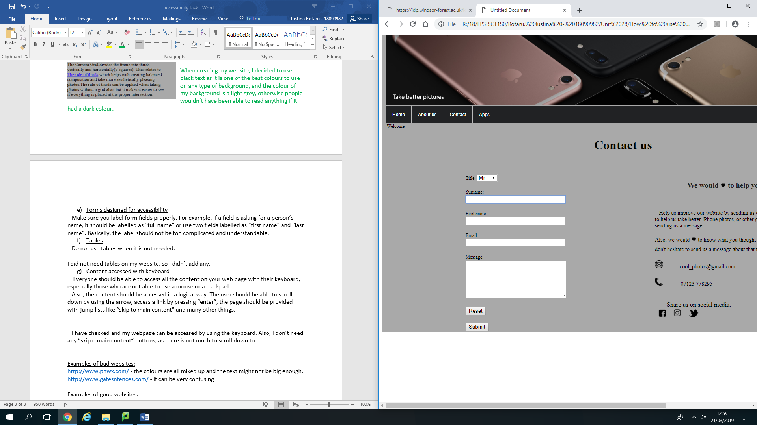

This image shows how I have labelled all my field. I assume that all the names that I put for each of them are all properly chosen.

1. Tables

Do not use tables when it is not needed.

I did not need tables on my website, so I didn’t add any.

1. Content accessed with keyboard

Everyone should be able to access all the content on your web page with their keyboard, especially those who are not able to use a mouse or a trackpad.

Also, the content should be accessed in a logical way. The user should be able to scroll down by using the arrow, access a link by pressing “enter”, the page should be provided with jump lists like “skip to main content” and many other things.

I have checked and my webpage can be accessed by using the keyboard. Also, I don’t need any “skip o main content” buttons, as there is not much to scroll down to.

Examples of bad websites:

<http://www.pnwx.com/> - the colours are all mixed up and the text might not be big enough.

<http://www.gatesnfences.com/> - it can be very confusing

Examples of good websites:

<https://www.amazon.co.uk/?&tag=hydraamazonav-21&ref=pd_sl_781ozcfkw8_e&adgrpid=52740778523&hvpone=&hvptwo=&hvadid=259053350854&hvpos=1t1&hvnetw=g&hvrand=8130774856887954522&hvqmt=e&hvdev=c&hvdvcmdl=&hvlocint=&hvlocphy=1007080&hvtargid=kwd-10573980> - Everything is well organised, nice choice of colours

<https://www.cadigal.com.au/>